Marie Kelling
 | Your Answers
1 | Result Grid | 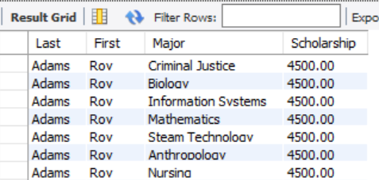
1 | SQL Text | -- 9.1 Marie Kelling  -- List students with a scholarship greater than the average scholarship for the school  USE college;  SELECT  LastName AS 'Last',  FirstName AS 'First',  Major.Name AS 'Major',  Scholarship  FROM  Student  INNER JOIN  Major ON Student.MajorID = MajorID  WHERE  Scholarship > (SELECT  AVG(Scholarship)  FROM  Student)  ORDER BY LastName;
2 | Result Grid | 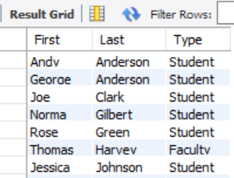
2 | SQL Text | -- 9.2 Marie Kelling  -- Use a UNION statement to combine the students and faculty into a single result set  USE college;  SELECT  FirstName AS 'First', LastName AS 'Last', 'Student' AS Type  FROM  Student  WHERE  MajorID = 5  UNION  SELECT  FirstName AS 'First', LastName AS 'Last', 'Faculty' AS Type  FROM  Faculty  WHERE  DepartmentID = 3  ORDER BY Last;
3 | Scholarships view
3 | Screen shot of the result grid from SELECT * FROM StudentScholarships  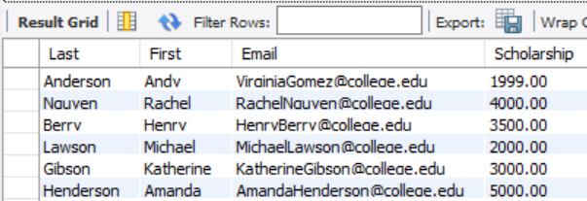
3 | Screen shot of your Schema window showing the scholarships view with its columns expanded  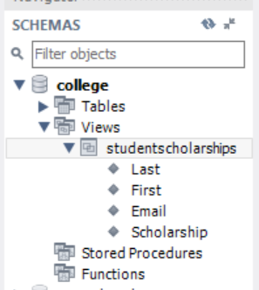
3 | Text of your CREATE VIEW SQL  -- 9.3 Marie Kelling  -- Create a view that shows all students receiving a non-zero scholarship  USE college;  CREATE OR REPLACE VIEW StudentScholarships AS  SELECT  LastName AS 'Last', FirstName AS 'First', Email, Scholarship  FROM  Student  WHERE  Scholarship > 0;
4 | Student Flatten View
4 | Screen shot of the result grid from SELECT * FROM StudentFlatten  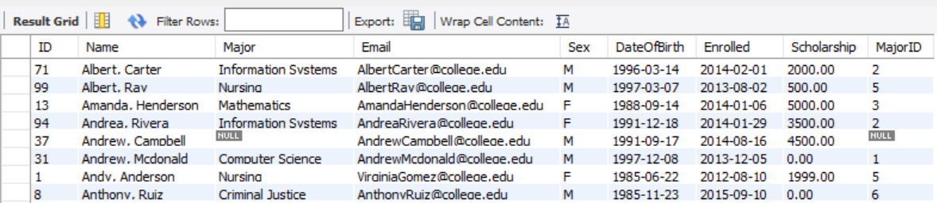
4 | Screen shot of your Schema window showing the view with its columns expanded  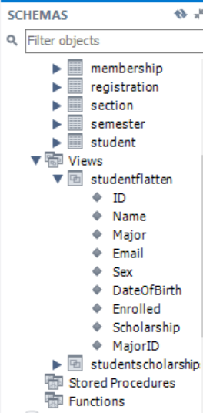
4 | Text of your CREATE VIEW SQL  -- 9.4 Marie Kelling  -- Create view that produces the required student information with an outer join  USE college;  CREATE OR REPLACE VIEW StudentFlatten AS  SELECT  Student.ID,  CONCAT(FirstName, ', ', LastName) AS Name,  Major.Name AS 'Major',  Email,  Sex,  DateOfBirth,  EnrolledDate AS 'Enrolled',  Scholarship,  MajorID  FROM  Student  LEFT OUTER JOIN  Major ON Student.MajorID = Major.ID  ORDER BY Name;
Discussion of how this view might be useful
This view could definitely be useful when you want to produce all the data about each of the students. This query produces every piece of information you might need to know about the students in the database. And by creating the view, it would be easy to reuse these statements instead of having to write out each column name and outer joining the student and major table.

5 | Nursing view
5 | Screen shot of the result grid Nursing Students with a scholarship  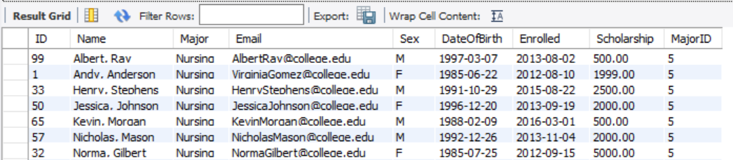
5 | Screen shot of your Schema window showing the view with its columns expanded  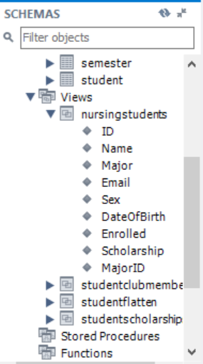
5 | Text of your CREATE VIEW SQL  -- 9.5 Marie Kelling  -- List all students majoring in nursing  USE college;  CREATE OR REPLACE VIEW NursingStudents AS  SELECT  *  FROM  StudentFlatten  WHERE  MajorID = 5;
Discussion of why you shouldn’t select on the name of the major.
You should not select on the name of the major because this name could easily and frequently be changed. It is more efficient to select on the major ID because it will remain constant.

6 | Roll-your-own View
6 | Screen shot of the result grid from SELECT * FROM your view  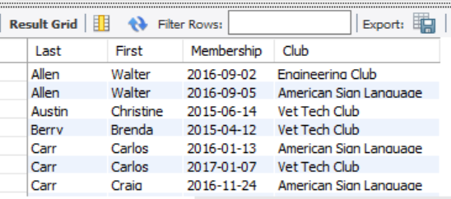
6 | Brief explanation of the purpose of your view. Tell me what it’s for, not how it works.  This view is used to list all the students in the database and display the clubs they are involved in, as well as the date their membership started in that club  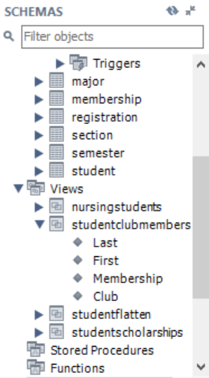
6 | Text of your CREATE VIEW SQL  -- 9.6 Marie Kelling  -- DIY Create view of your choice using 3 joins, one being an outer join  USE college;  CREATE OR REPLACE VIEW StudentClubMembership AS  SELECT  LastName AS 'Last',  FirstName AS 'First',  Membership.DateJoined AS 'Membership',  Club.Name AS 'Club'  FROM  Student  INNER JOIN  Membership ON Student.ID = Membership.StudentID  LEFT OUTER JOIN  Club ON Membership.ClubID = Club.ID  ORDER BY Last , First;

